Genealogy Organizing
By
Len Enlow

- Various Storage Techniques:
  - Computer Hard Drive
  - Filing Cabinets, and File Folders
  - 3-Ring Binders
  - Computer Disks, Flash Drives, CD’s, DVD’s
- Common Filing Systems
  - By Surname
  - By Couple
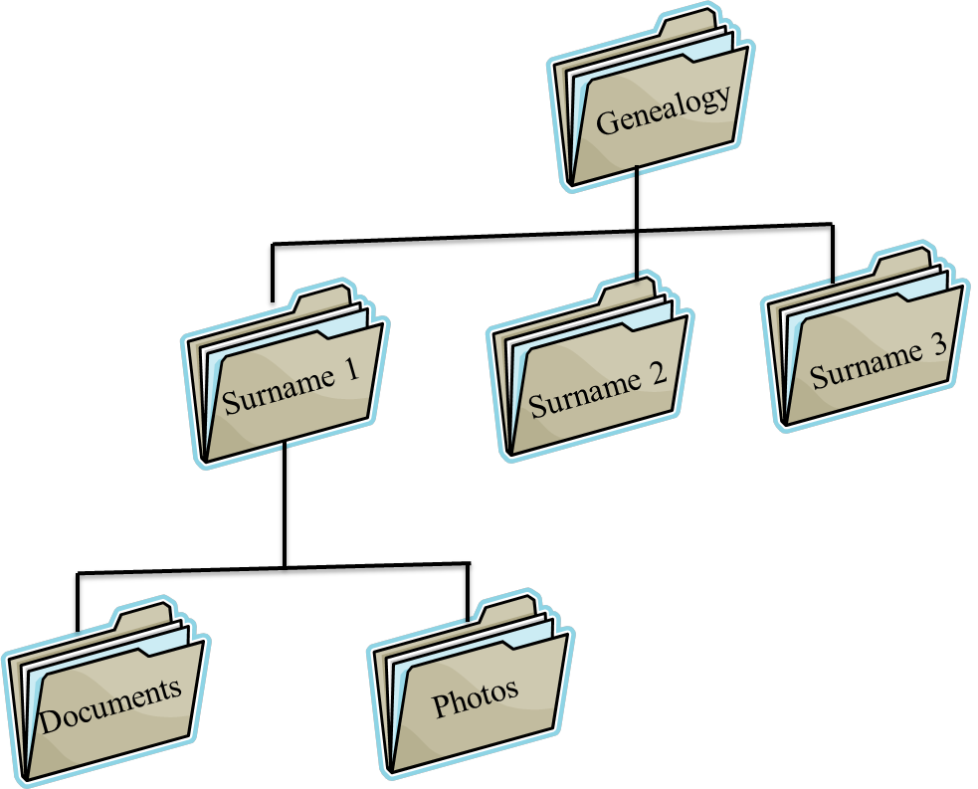
  - By Family Line
  - By Event
    - Birth, death, marriage, etc.
- You will Probably Use Some of Each System
  - Binders
  - Folders
  - Software
- Software I Use
  - Family Tree Maker 2014
  - Excel
  - Word
  - PowerPoint
  - Publisher
- Computer Hard Drive Organization
  - Under “Documents” make a folder called “Genealogy”
  - Under Genealogy, make sub-folders for each Surname
  - Under each Surname You can make other subfolders, such as:
    - Birth
    - Census
So, I will store scans, of the various items, into these folders. You can also add a folder for photos under each Surname. I choose to make a folder under “Pictures” called Genealogy, and then under that make subfolders for each surname.
    - Death
    - Documents
    - Immigration
    - Land
    - Marriage
    - Military
    - Newspaper
    - Occupations
    - Stories

- Family Tree Software
  - Family Tree Maker
  - RootsMagic
  - Legacy
  - Family Tree Builder
  - Master Genealogist
  - Reunion
- I use Family Tree Maker Software.
  - That program stores the database in a folder called “Family Tree Maker 2014”
  - It stores all the scans and photo in that folder called “Media File”

Lists Help in Organizing
- Census Records
  - Make list of all census records you have
- Names
  - Make list of all names in your data file
- Family Books
  - Make book on direct ancestors
  - Make book of all members
- Lists
  - Make lists of all people you have cemetery names for
  - Make Research Journal, Correspondence Log, Online Search Tracker, etc.
  - Make custom lists/forms
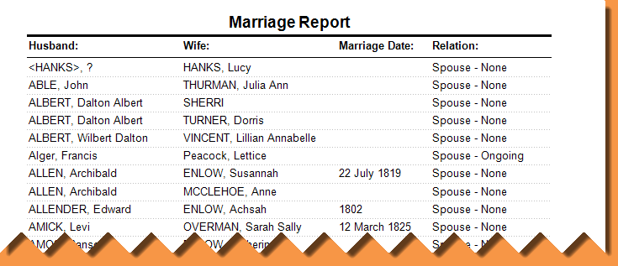
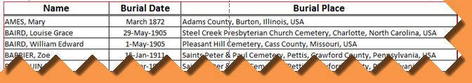

Digital Photo Organizing

- Thin your pictures out
  - Delete duplicates
  - Delete ones you don’t need

- Give them descripting names
  - Eiffel_Tower_May_2008.jpg

- Do not use special characters in the new file name
  - / \ < > ^ + =
  - You can use underscore, period, or dash
- In my genealogy photos I start name with the SURNAME first
  - enlow-abe_1790_pa_census.jpg
  - enloes-isaac_rev_war_record.jpg
  - enlow-charles_texas_death_cert.jpg
  - enlow-elliott_backside_wedding_doc.jpg
  - brunot-claude_headstone.jpg
  - Pernatt-Roy_and_opal_portrait.jpg

- Create descriptive folders to store them in
  - In my personal photos my top folder is the year and then I add sub folders under that for events.
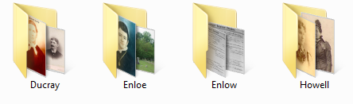
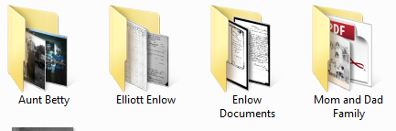
  - In my genealogy I use SURNAME as the top folder and under that I add folders with specific names.
