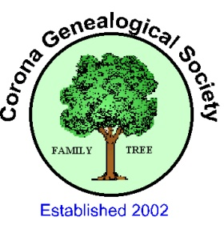
Corona Genealogical Society
Web Site: www.coronagensoc.org
Corona Public Library Phone: (951) 739-4860
650 S. Main Street www.coronapubliclibrary.org
Corona, CA 92882-3417

Application for Membership:

DATE:
NAME:

ADDRESS:

PHONE:
E-MAIL:

GENEALOGY LEVEL: SURNAMES RESEARCHING
__________________________________________________________________________________________________________________________________________________________________________________________________________________
Beginner ________
Medium: ________
Advanced: _______

Yearly Fees are $20/individual or $25/household. For those joining after Sept. 1, fees are $10/individual or $15/household. Please make checks payable to Corona Genealogical Society and bring this form and fee to the monthly meeting, one of the Friday afternoon classes, or mail to:
Gary Cowan, Treasurer
1924 Pamela St.
Corona, CA 92879

